

**Experiment – 1**

**WEATHER MODELLING USING QUADRATIC EQUATION**

**Software Engineering**

By

**Vulasala Sujan (BU22CSEN0101959)**

Under the Guidance of

**Kerenalli Sudarshana (700542)**

Gandhi Institute of Technology and Management

(DEEMED TO BE UNIVERSITY)

BENGALURU, KARNATAKA, INDIA

Academic Year 2024-25

**INDEX**

* **Aim**
* **Algorithm Development**
* **Execution**
* **Result**

**Aim: -** Implement weather modelling using the quadratic solution in stages:

* Hard-coding variables.
* Keyboard input.
* File input for a single set of data.
* File input for multiple sets of data.
* Save all versions, debug, fix issues, create a GitHub account, and version the files.

## **Algorithm Versioning: -**

**Step 1**: Create a GitHub account.

**Step 2**: Create a repository on GitHub and collect its URL.

**Step 3**: Create a local repository and write the program for **Version 1 (hard-coding variables)**.

**Step 4**: Use the following commands to push Version 1 to GitHub:

* git init
* git add README.md
* git commit -m "first commit"
* git branch -M main
* git remote add origin <repository_url>
* git push -u origin main

**Step 5**: Modify the program to implement **Version 2 (keyboard input)**.

**Step 6**: Push Version 2 to GitHub using the same commands as Step 4.

**Step 7**: Modify the program for **Version 3 (file input for a single set of data)**.

**Step 8**: Push Version 3 to GitHub.

**Step 9**: Modify the program for **Version 4 (file input for multiple sets of data)**.

**Step 10**: Push Version 4 to GitHub.

**Execution: -**

**Version1:Hard Coding Variables :-**

**Program outputs for version1: -**

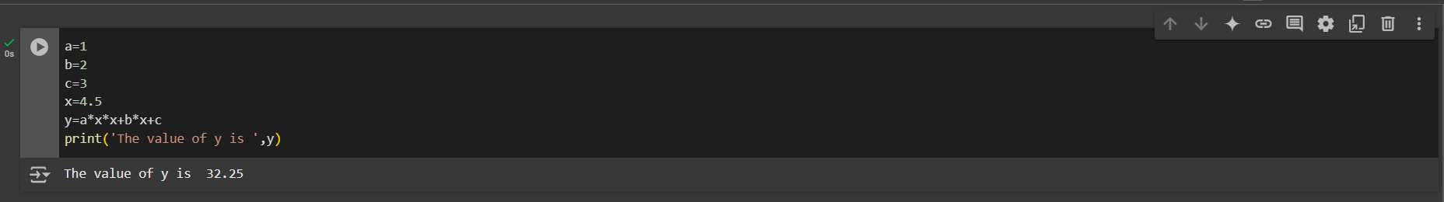

**Version2:Keyboard Input**

**Program outputs for version2:**

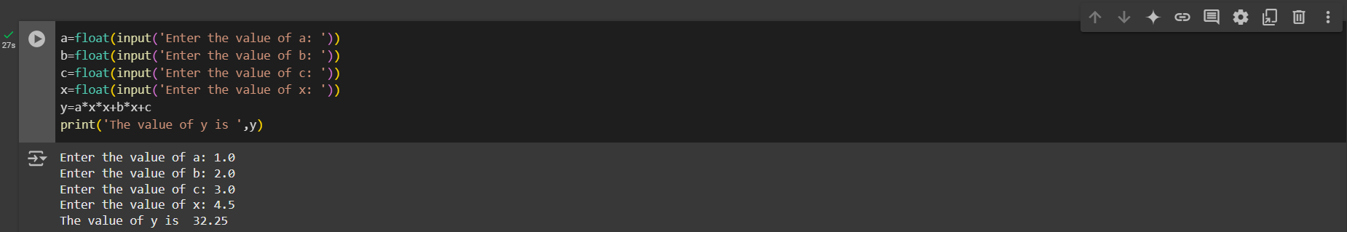

**Version3:File input for single set of data**

**Program outputs for version3:**

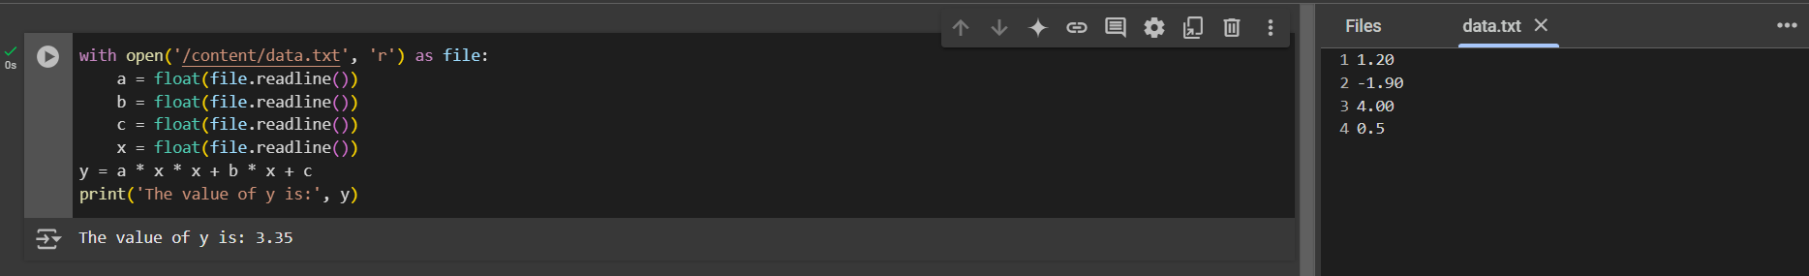

**Version4:File input for multiple sets of data**

**Program outputs for version2:**

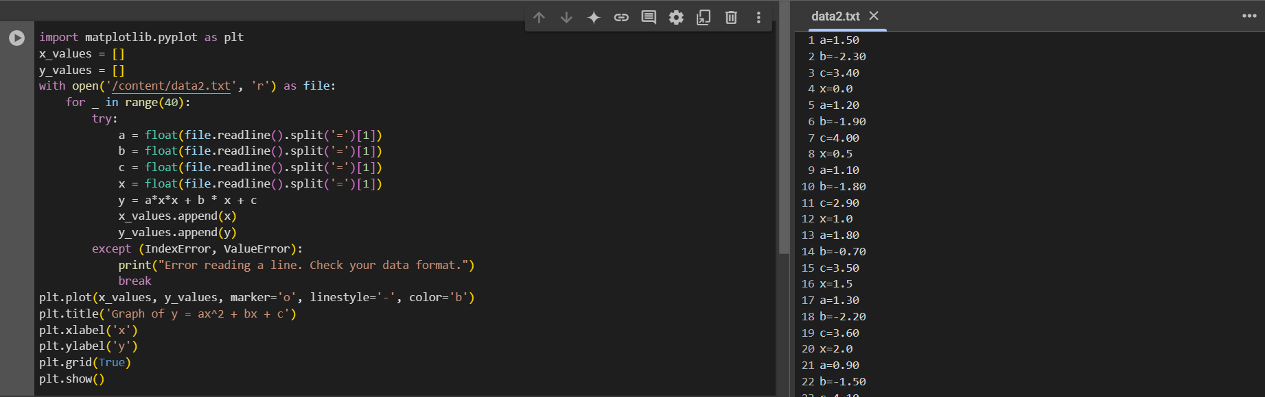

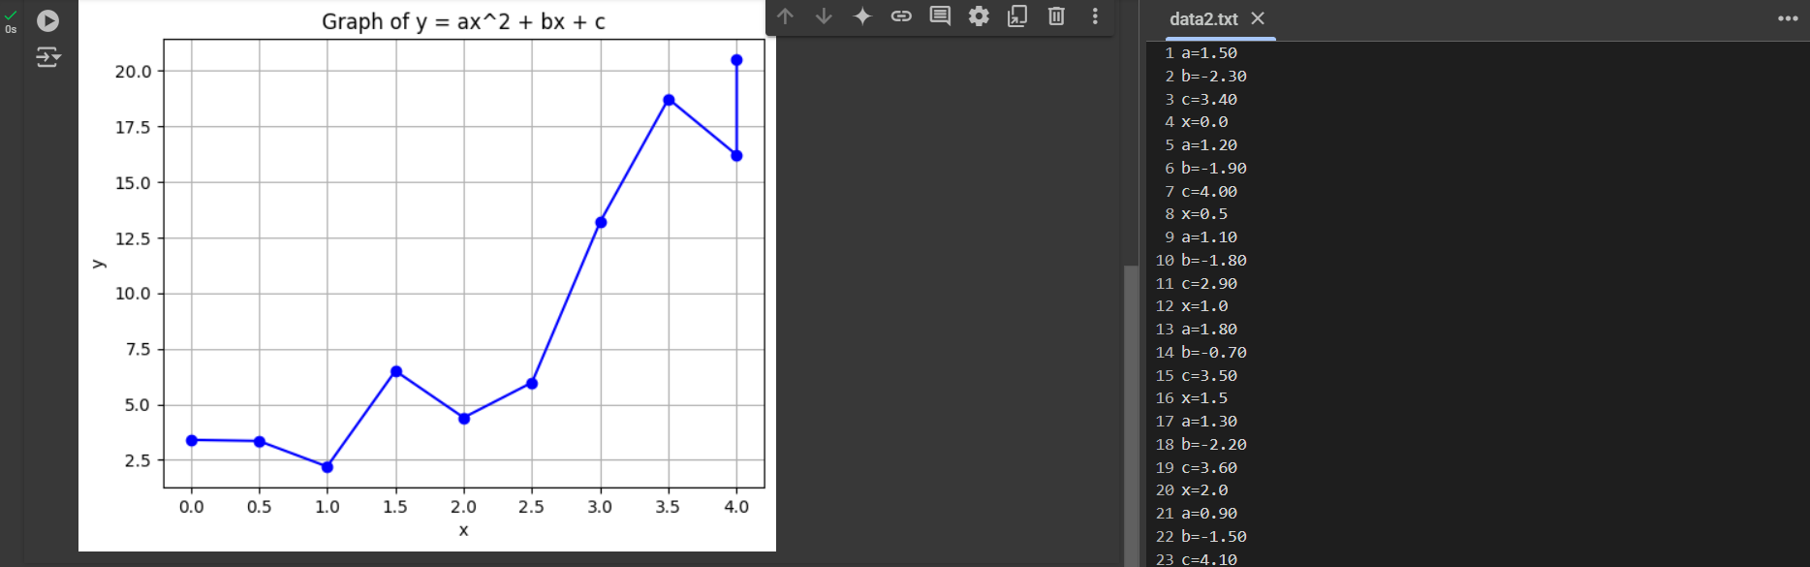

**GitHub Commit History :-**

**GitHub commit history for v1: -**

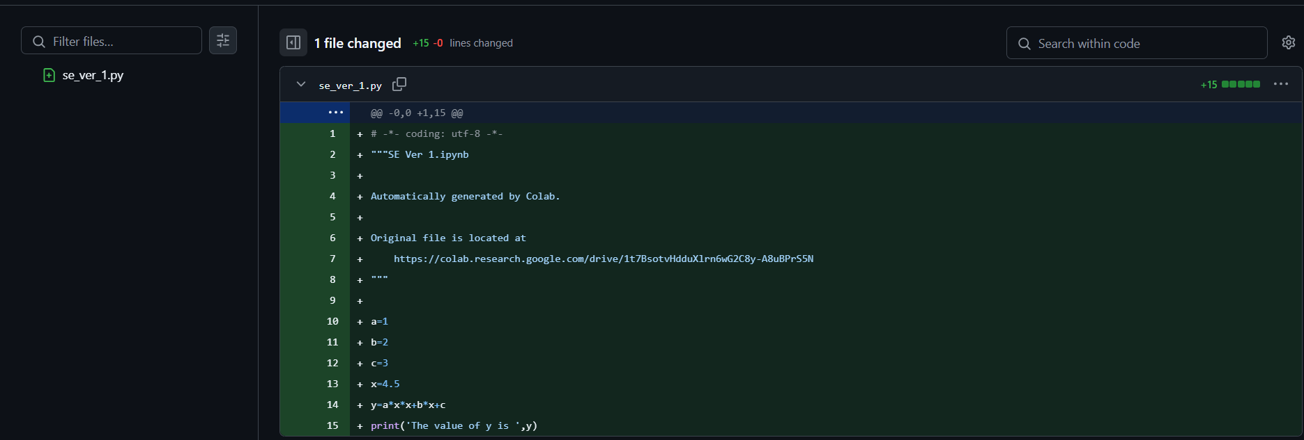

**GitHub commit history for v2 :-**

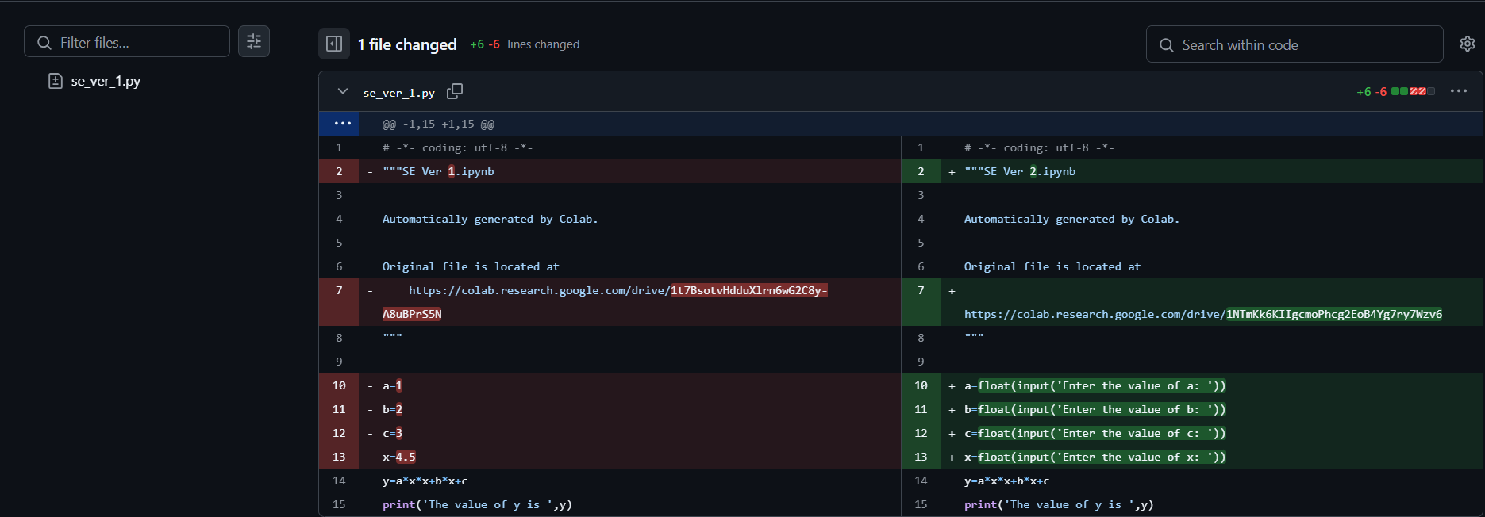

**GitHub commit history for v3 :-**

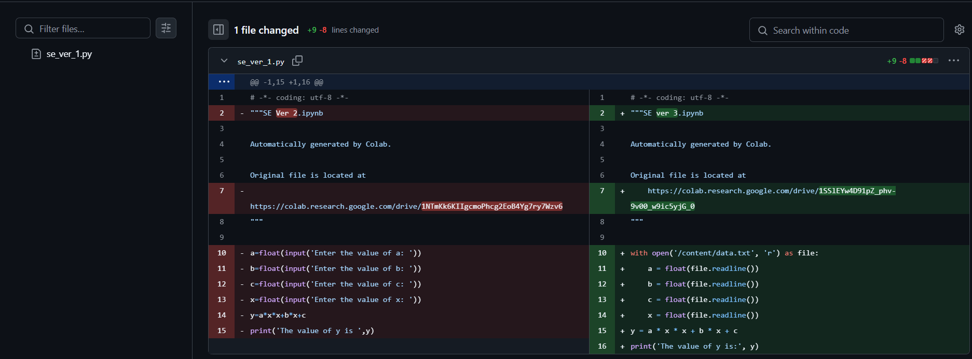

**Data for v3: -**

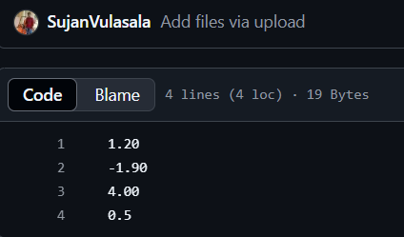

**GitHub commit history for v4 :-**

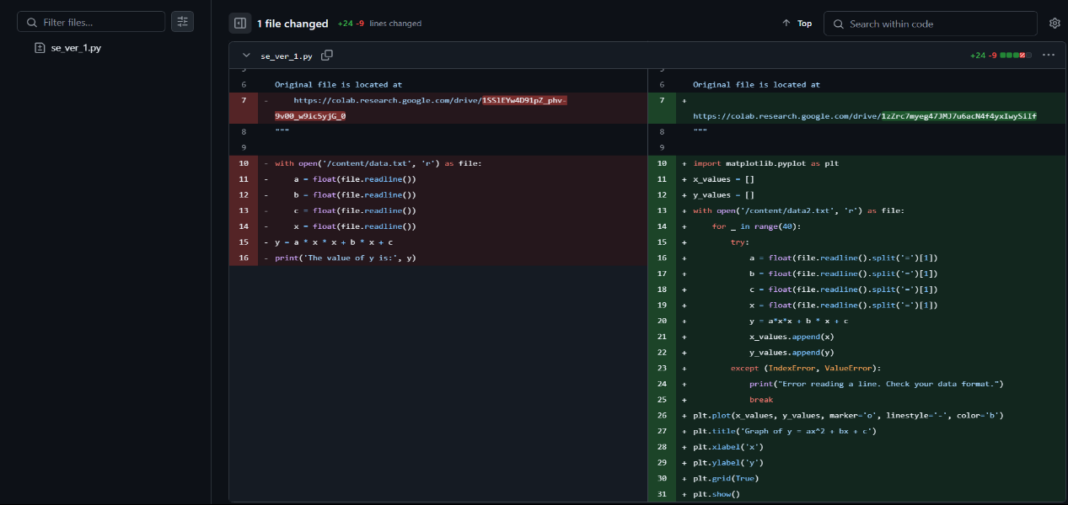

**Data for v4: -**

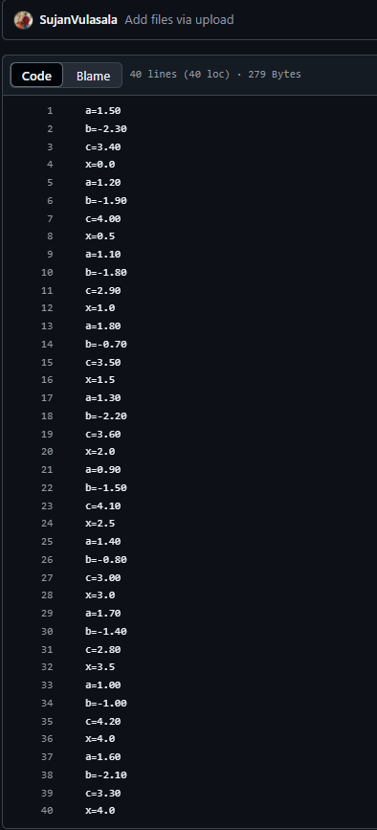

**Result: -**

A weather modelling system was successfully implemented using the quadratic solution in stages. The code was versioned and saved on a GitHub repository, and all versions were documented for reference.